ERC-20 Token-Based Donation Platform

A PROJECT REPORT
Submitted by
Abinash Behera
Amit Pradhan
Akshya Ku Behera
Swornapriya Patra
Suchismita Priyadarshini
in partial fulfilment for the award of the
degree of
BACHELOR OF TECHNOLOGY
in
COMPUTER SCIENCE AND ENGINEERING

SCHOOL OF ENGINEERING AND TECHNOLOGY
BHUBANESWAR CAMPUS
CENTURION UNIVERSITY OF TECHNOLOGY AND MANAGEMENT
ODISHA
NOVEMBER 2025

DEPARTMENT OF COMPUTER SCIENCE AND ENGINEERING SCHOOL OF ENGINEERING AND TECHNOLOGY BHUBANESWAR CAMPUS
BONAFIDE CERTIFICATE
This is to certify that the project titled “Design and Implementation of a Decentralized ERC-20 Token-Based Donation Platform using Ethereum” has been carried out by Abinash Behera (230301120453), Amit Pradhan (230301120443), Akshya Ku Behera (230301120450), Swornapriya Patra (230301120470), and Suchismita (230301120052) under the guidance of Prof. Abhi Mitra in partial fulfillment of the requirements for the award of the degree of Bachelor of Technology in Computer Science at Centurion University

Signature of Supervisor

Certified that the above-mentioned project has been duly carried out as per the norms of the collage and statutes of the university

Signature of Head of the Department
Designation: Professor / Associate Professor /Asst. Professor
_

ACKNOWLEDGEMENTS
I wish to express my profound and sincere gratitude to Prof. Abhimitra sir Department of Computer Science and Engineering, SoET, Bhubaneswar Campus, who guided me into the intricacies of this project nonchalantly with matchless magnanimity.
I thank Prof. Rajkumar Mohanta, Head of the Dept. of Department of Computer Science and Engineering, SoET, Bhubaneswar Campus and Dr. Sujata Chakravarty, Dean, School of Engineering and Technology, Bhubaneswar Campus for extending their support during Course of this investigation.
I would be failing in my duty if I don’t acknowledge the cooperation rendered during various stages of image interpretation by Prof. Abhimitra sir
I am highly grateful to by Prof. Abhimitra sir who evinced keen interest and invaluable support in the progress and successful completion of my project work.
I am indebted to by Prof. Abhimitra sir for their constant encouragement, cooperation and help. Words of gratitude are not enough to describe the accommodation and fortitude which they have shown throughout my endeavor.

Name of the Student:

Signature of the Student:
Registration No: 230301120450
Place: Bhubaneswar
Date:

.

Abstract:-

This project presents a decentralized donation platform that accepts ETH and ERC-20 token donations. It leverages Ethereum smart contracts to ensure transparency, security, and immutability of donation records. A React-based frontend interacts with the blockchain via ethers.js, enabling seamless user experiences without intermediaries. The platform demonstrates real-time, event-driven UI updates and supports campaign-based donation tracking, allowing donors to monitor how their funds are utilized. Additionally, the system promotes trustless transactions, ensuring that donations are securely transferred directly to campaign smart contracts. The project highlights the potential of Web3 technologies in creating transparent and community-driven charitable ecosystems, paving the way for a more accountable and decentralized fundraising model.

Table of Contents:-

1. Introduction
2. Literature Review
3. System Design and Architecture
4. Smart Contract Implementation
5. Frontend Implementation
6. Testing and Results
7. Conclusion and Future Work
8. References
9. Appendix

1. Introduction:-
Blockchain technology provides a decentralized ledger that is tamper-resistant and transparent. This property makes it ideal for building donation platforms where accountability is crucial. The project focuses on enabling donors to contribute ETH or ERC-20 tokens to charity campaigns via smart contracts. Donations are logged on-chain and surfaced to users in real time.
1.1 Objectives:-
- Design a secure smart contract to handle ETH and ERC-20 donations.
- Build a React frontend integrating with MetaMask and ethers.js.
- Provide per-campaign tracking and recent donation history.
- Demonstrate event-driven updates and owner controls for withdrawals.

2. Literature Review:-

Existing blockchain donation platforms, such as Giveth, provide decentralized giving solutions. Research indicates that blockchain improves transparency but introduces usability and cost challenges. This project aims to provide a lightweight, easy-to-deploy platform with ERC-20 token support and a simple UI for donors.

3. System Design and Architecture:-

The system consists of three main layers:
1. Smart Contracts: DonationManager and CharityWallet handle logic and event emission.
2. Frontend: React application using ethers.js to interact with contracts and display donation history.
3. (Optional) Backend: A node server can index events — not used in this project.
Figure 1 shows the conceptual architecture: donors -> frontend -> smart contract -> charity wallet; events flow back to frontend.
[Figure 1: System Architecture Diagram - donors -> frontend (React) -> DonationManager.sol / CharityWallet.sol -> Blockchain]
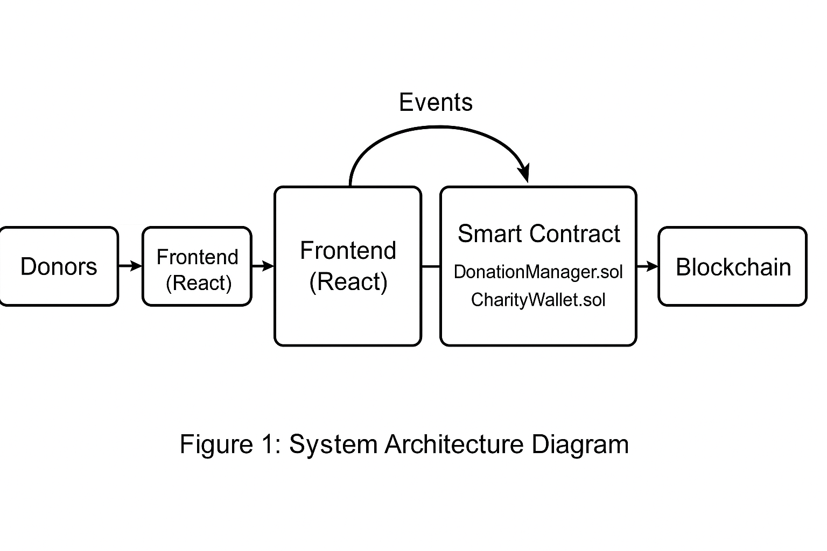

4. Smart Contract Implementation:-
Two primary contracts were implemented:
DonationManager.sol:
- Handles ERC-20 token donations via donate(token, amount, campaignId).
- Emits DonationReceived events.
CharityWallet.sol:
- Receives ETH donations (forwarded from frontend) or via DonationManager.
- Emits ETHDonation events on receiving funds.
Both contracts use OpenZeppelin libraries for security and follow best practices like checks-effects-interactions.
Figure 4.1DonationManager.sol screenshot 1
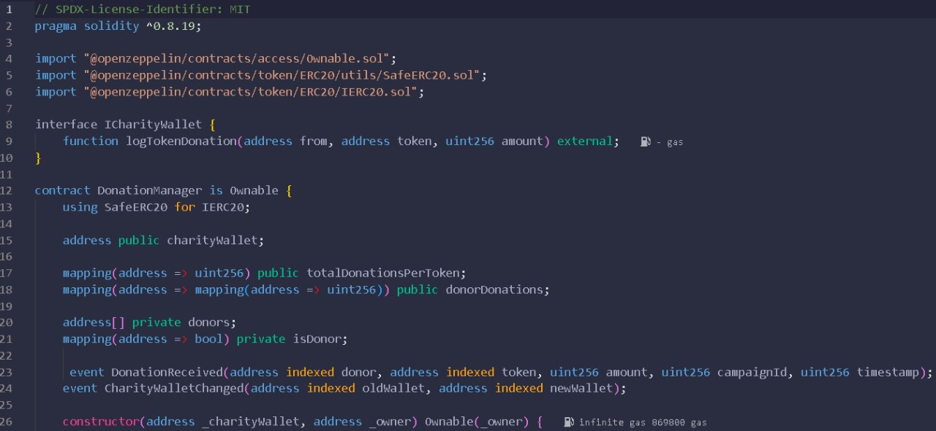
Figure 4.2DonationManager.sol screenshot 2:-
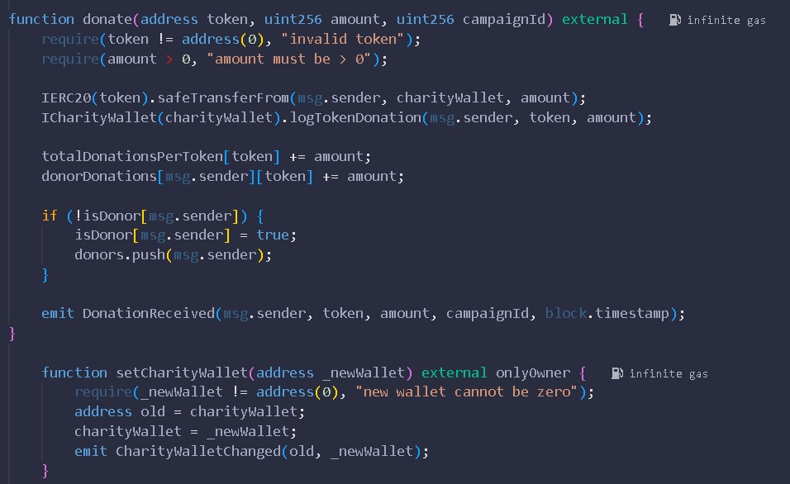

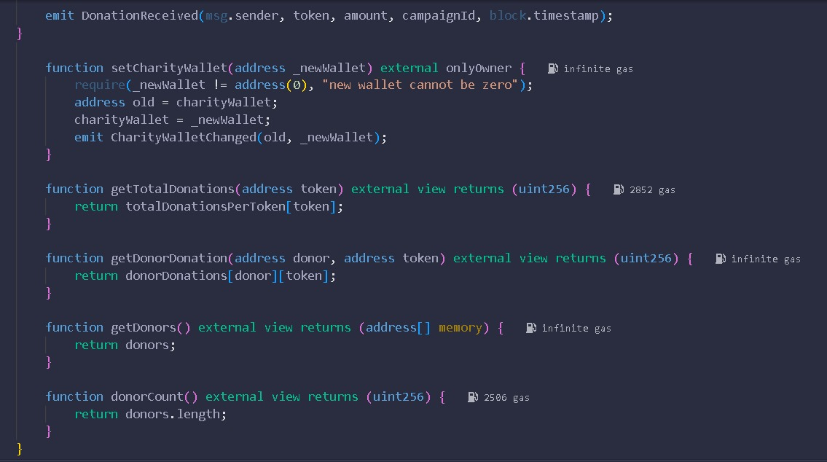
Figure 4.3DonationManager.sol screenshot3:-

Figure 4.4CharityWallet.sol: screenshot1:-
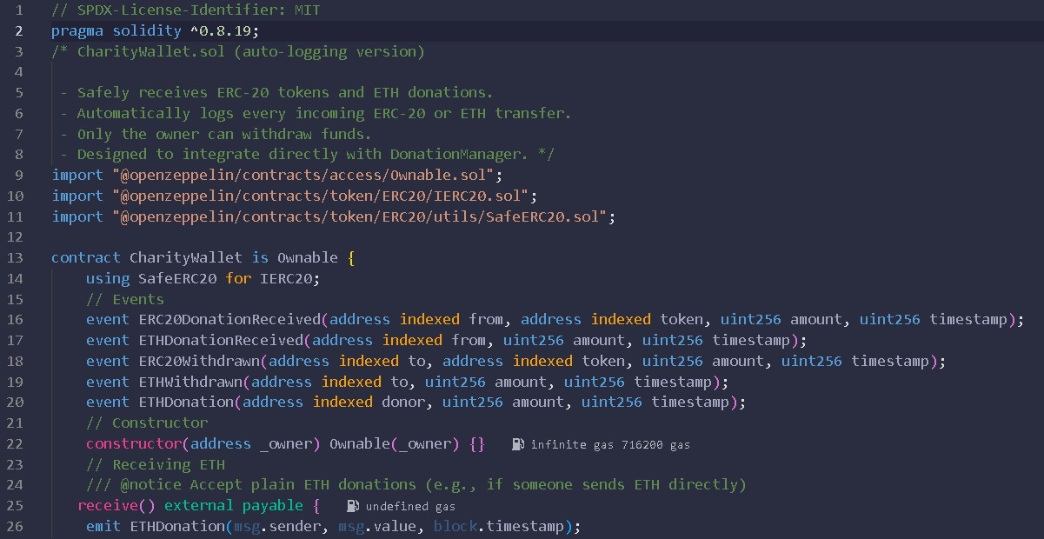

Figure 4.5CharityWallet.sol: screenshot2:-
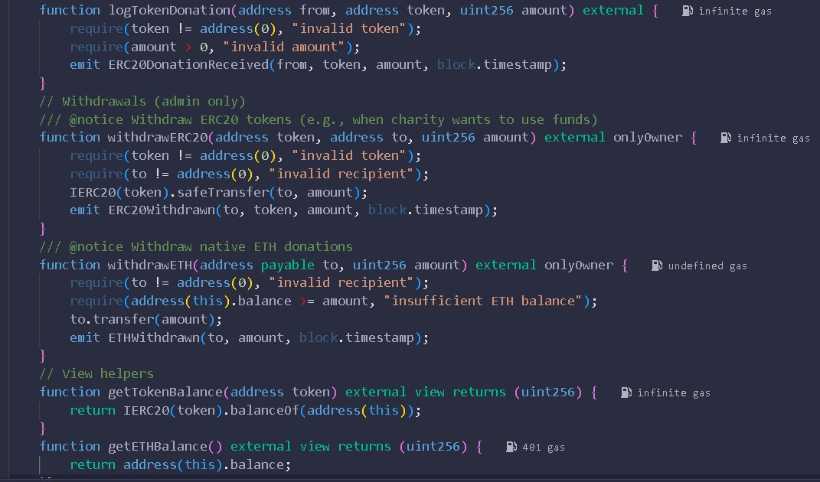

5. Frontend Implementation (React + ethers.js):-
The frontend is built with React and uses ethers.js to connect to MetaMask. Key features:
- Connect wallet and display connection status.
- Donation form supporting ETH and ERC-20 tokens (approve + donate).
- Recent Donations list updated by listening to DonationReceived and ETHDonation events.
- Summary boxes showing total ETH and token donations and per-campaign totals.
The following screenshots show important parts of the frontend code (App.js) and UI.
Figure 5.1: App.js screenshot 1
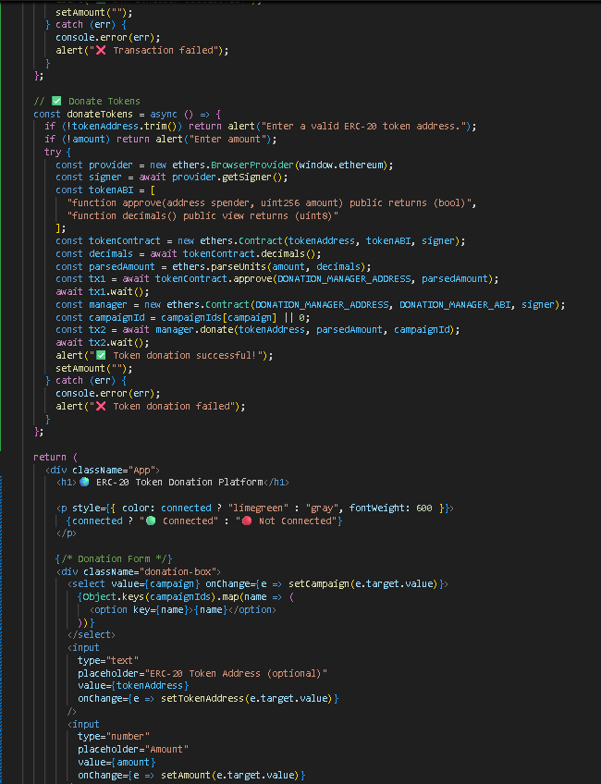

Figure 5.2: App.js screenshot 2:-
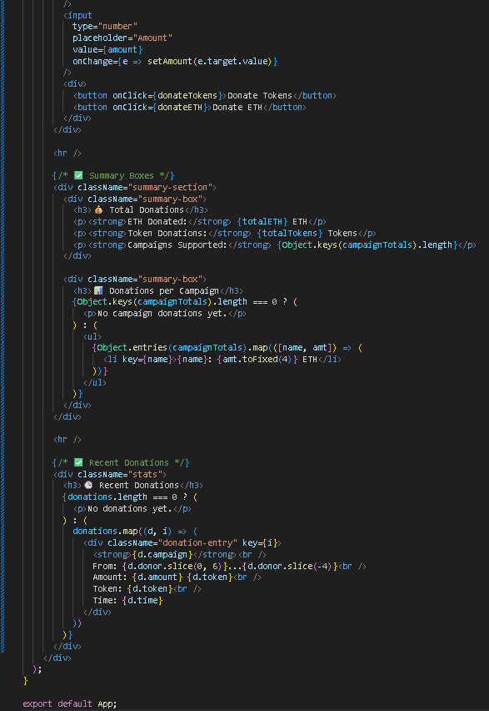

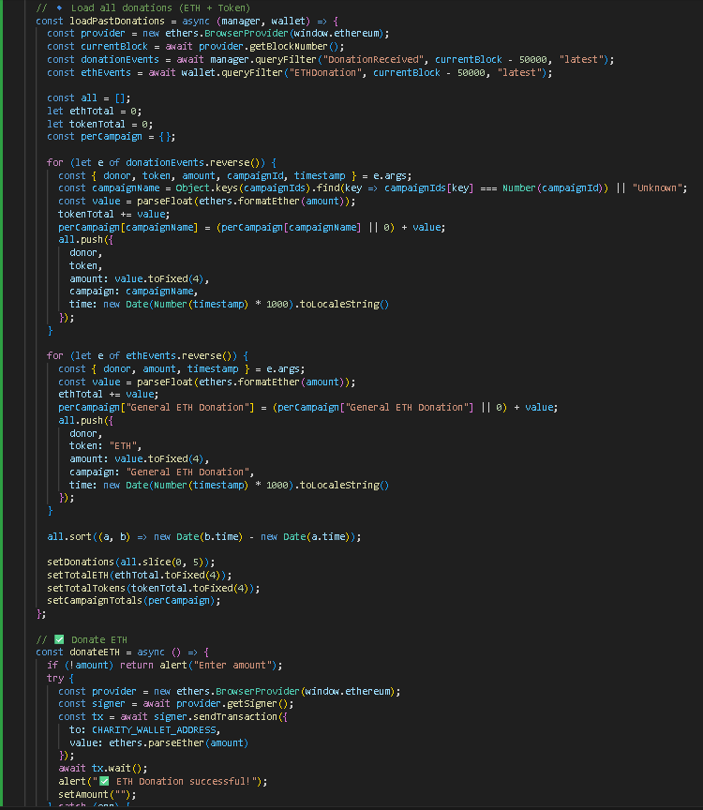
Figure 5.3: App.js screenshot 3:-
Figure 5.4: App.js screenshot 4:-
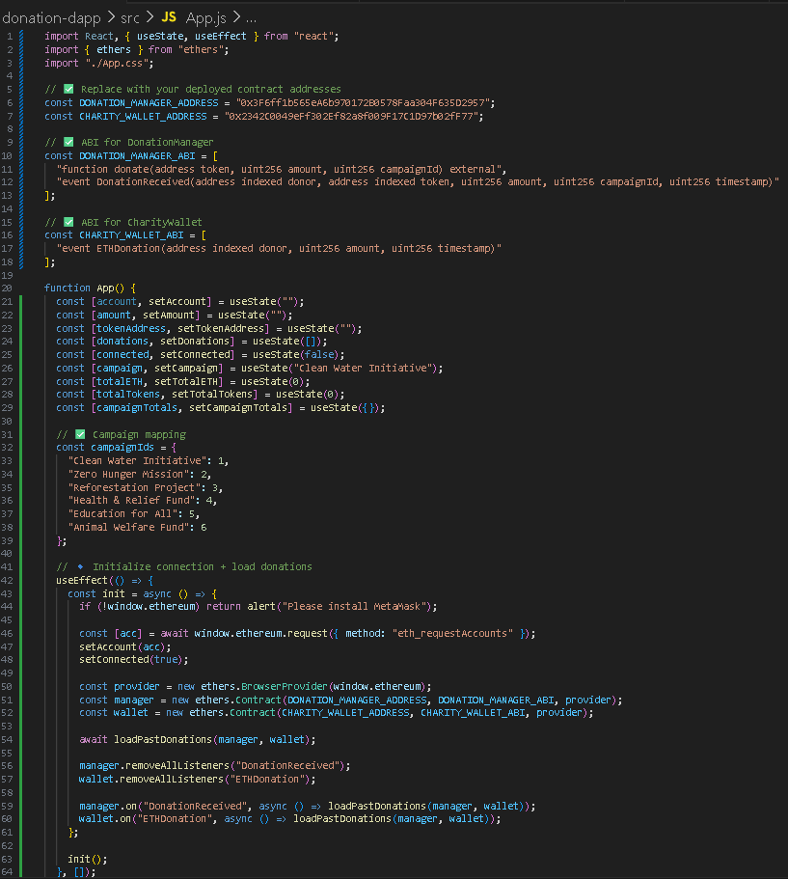

5.1 Frontend Flow:-
1. On load, the app requests MetaMask account access and connects the provider.
2. The app loads past DonationReceived and ETHDonation events using queryFilter and displays recent entries.
3. Event listeners are attached to update the UI in real time when donations occur.
4. For ERC-20 tokens, the frontend calls token.approve() then DonationManager.donate().
5. For ETH donations, the frontend sends a transaction to the CharityWallet address
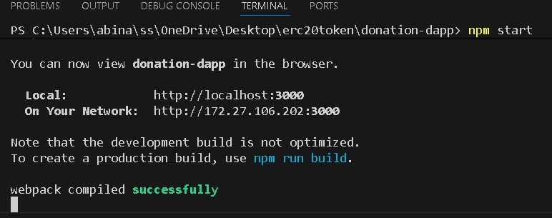
Screenshot-5.1.1.
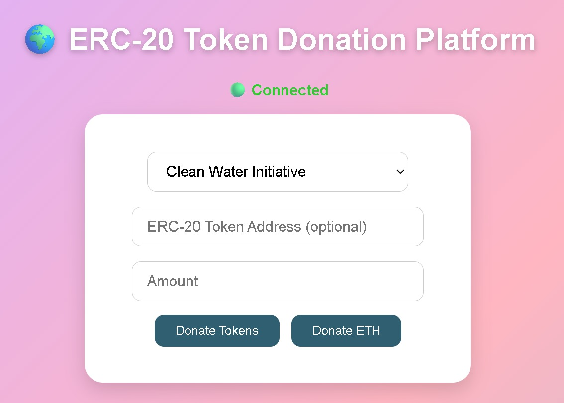
Screenshot-5.1.2

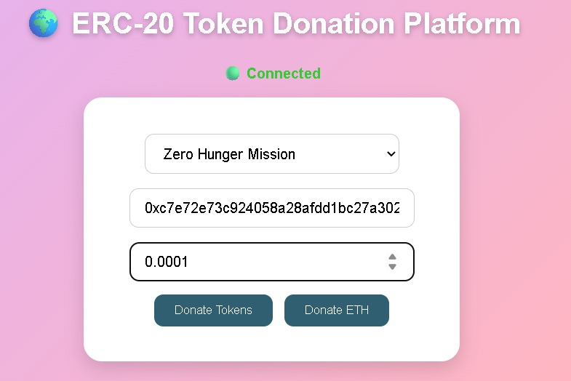
Screenshot-5.1.3:-

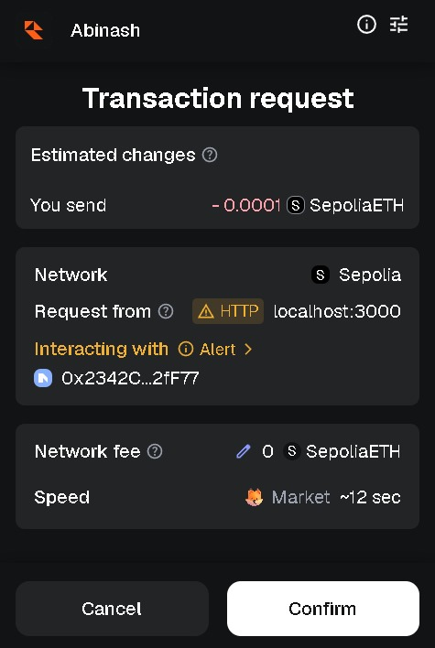
Screenshot-5.1.4:-

Screenshot-5.1.5:-
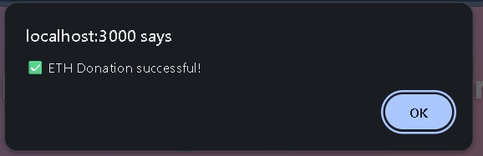

6. Testing and Results:-
Testing was performed on an Ethereum testnet. Functional tests included:
- ETH donation: verified the CharityWallet received funds and emitted ETHDonation events.
- ERC-20 donation: approved tokens and verified DonationReceived events were emitted and UI updated.
- Event listener robustness: ensured duplicate listeners were cleaned and UI showed single entries per transaction.
Sample result screenshots (frontend) are embedded in Chapter 5. The platform successfully recorded and displayed donations in real time.
Screenshot-6.1:-
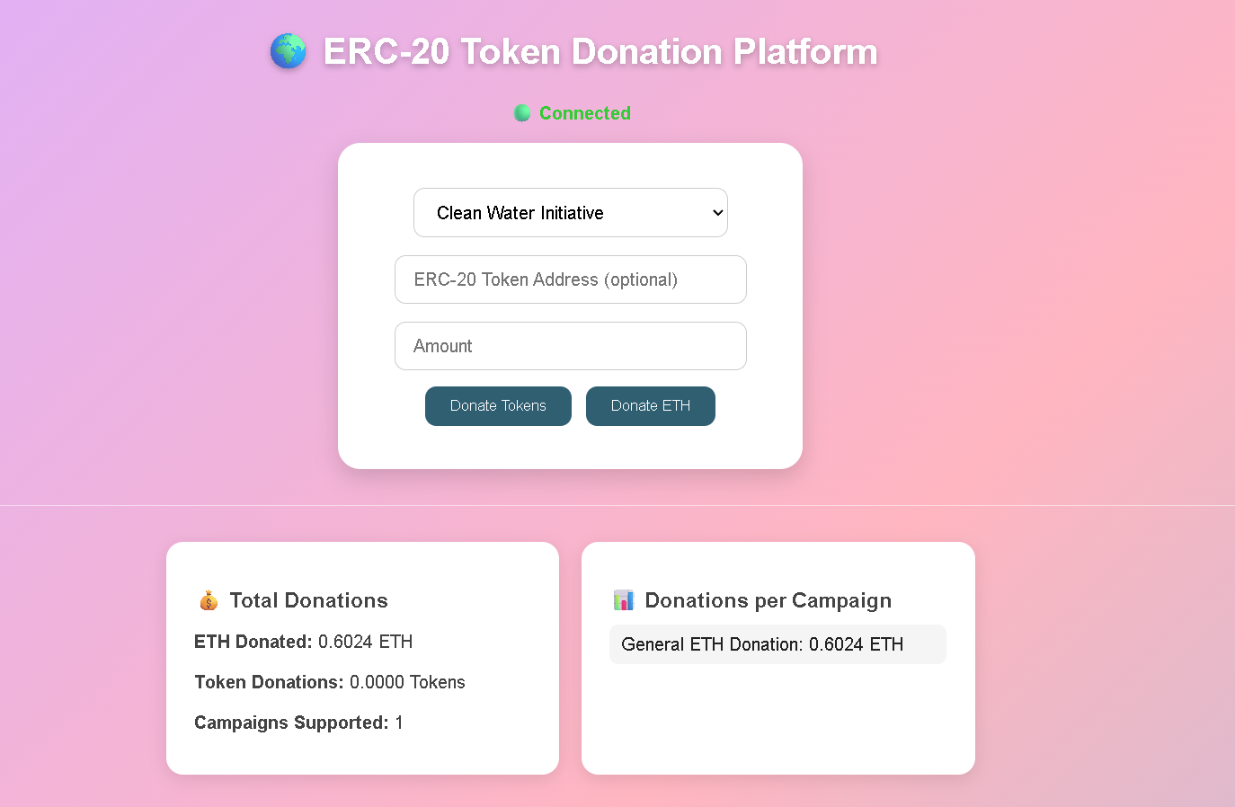
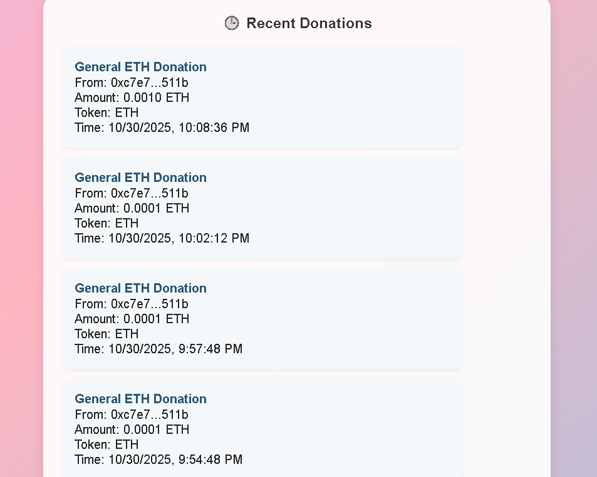
Screenshot-6.2:-

7. Conclusion and Future Work:-

This project demonstrates a practical decentralized application (DApp) designed to enable transparent, secure, and efficient donations using Ethereum and ERC-20 tokens. It highlights how blockchain technology can revolutionize the traditional donation ecosystem by eliminating intermediaries, reducing operational overheads, and fostering trust between donors and recipients.
The platform effectively utilizes smart contracts to automate donation tracking, enforce transparency, and ensure that all transactions are permanently and immutably recorded on the Ethereum blockchain. Through the integration of a React-based frontend and ethers.js, users can seamlessly interact with the blockchain network, monitor donation campaigns in real time, and verify fund transfers directly from their wallets.
In addition, the DApp demonstrates the power of event-driven architecture, where smart contract events trigger immediate UI updates, providing an engaging and responsive user experience. This transparency and traceability help build donor confidence while maintaining decentralization and data integrity.

References
Ethereum Foundation. Ethereum Smart Contracts documentation.
OpenZeppelin. OpenZeppelin Contracts - Secure Smart Contract Development.
MetaMask Developer Docs. Connecting dApps to MetaMask.
ethers.js Documentation. Interacting with Ethereum using ethers.js.
React Documentation. Building user interfaces with React.

Appendix A: Key Code Snippets (Summarized):-

DonationManager.sol - key functions (summary):
- donate(token, amount, campaignId): transfers ERC-20 tokens to charity and emits DonationReceived.
- donateETH(): payable function to forward ETH and emit ETHDonation.
- sendETH(recipient, amount): owner-only withdrawal function.
App.js - key logic (summary):
- connect wallet (ethers.BrowserProvider), attach listeners for events.
-loadPastDonations(): queryFilter for DonationReceived and ETHDonation and aggregate totals.
- donateTokens(): approve ERC-20 then call donate() on manager.
- donateETH(): send transaction to charity wallet address.

Appendix B: Deployment and Run Instructions:-

1. Smart contracts (Remix or Hardhat):
- Compile contracts using Solidity ^0.8.x
- Deploy DonationManager and CharityWallet to a testnet (e.g., Sepolia)
2. Frontend:
- Update contract addresses in App.js
- npm install
- npm start
3. Testing:
- Use MetaMask connected to the same network and account with test ETH
- For token donations deploy an ERC-20 test token or use an existing test token

Appendix C: Project Log and Team Contributions:-

Team Members and contributions:
- Abinash Behera: Frontend implementation and event-handling logic.
- Amit Pradhan: Smart contract design and testing.
- Akshya Ku Behera: UI/UX and CSS styling.
- Swornapriya Patra: Documentation and testing.
- Suchismita: Project coordination and report compilation.

DECLARATION
I hereby declare that the project entitled “ERC-20 Token-Based Donation Platform” submitted for the “Smart Engineering ” of 3rd Master in Computer Application is our original work, and the project has not formed the basis for the award of any Degree masters, or any other similar title in any other University / Institute.

Name of the Student:
Signature of the Student:
Registration No:
Place: Bhubaneswar
Date:

